
LTP Initial Code Reception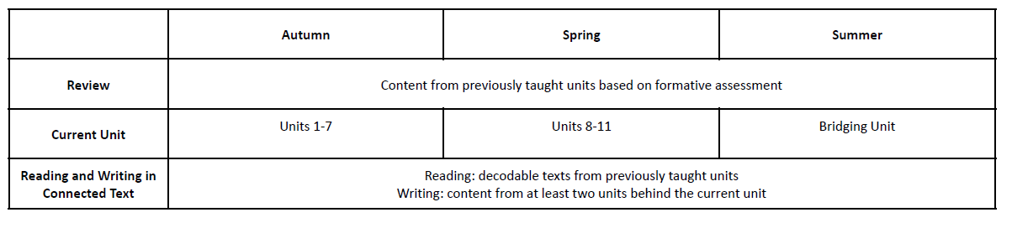

FS2 Autumn Units 1 - 7
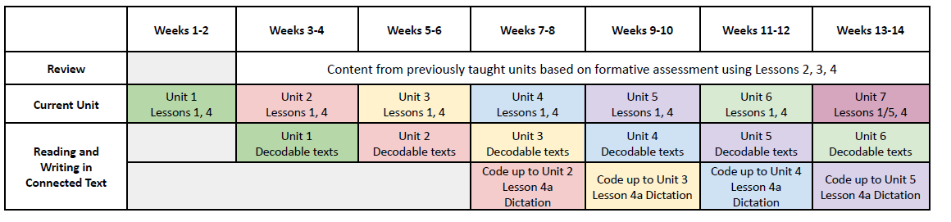

FS2 Spring Units 8 – 11
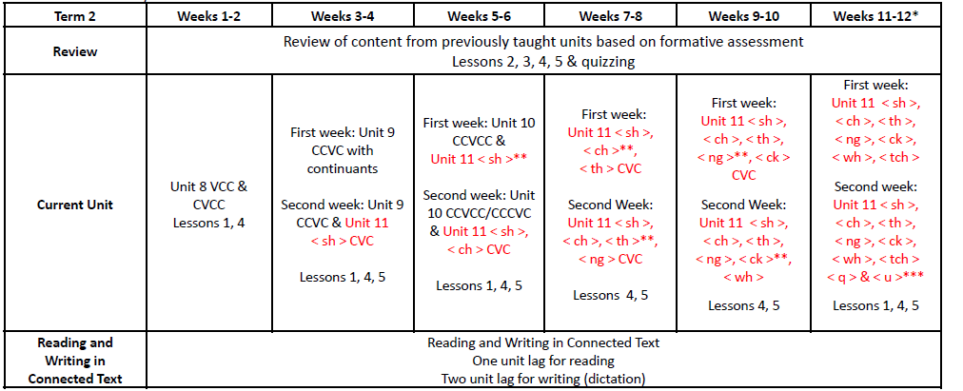

FS2 Summer Bridging Unit
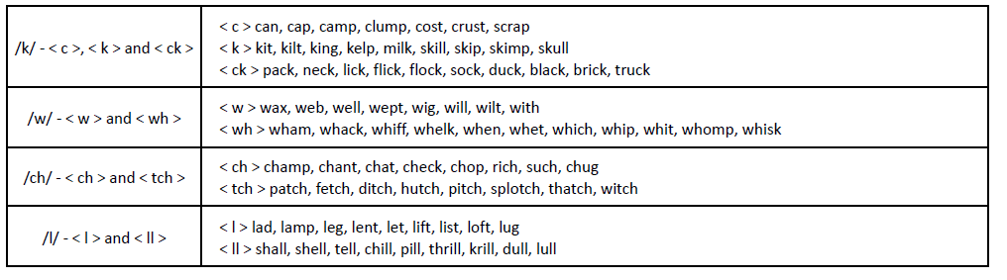
LTP Extended Code and Polysyllabic Words Year 1
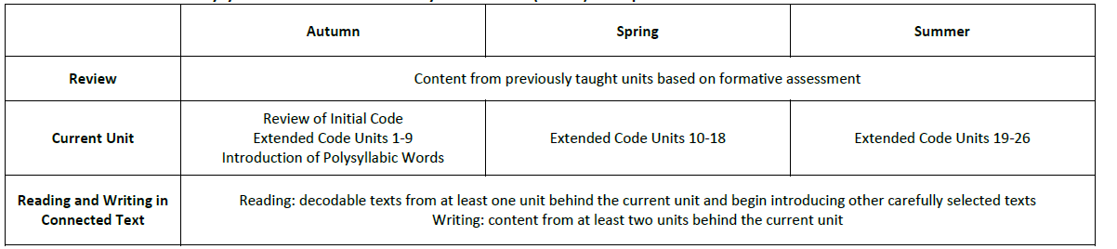

Year 1 Autumn Extended Code
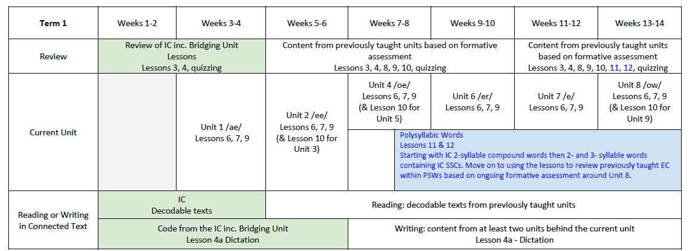
Year 1 Spring Extended Code
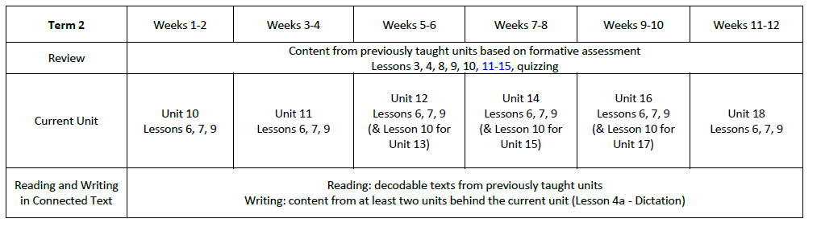

Year 1 Summer Extended Code
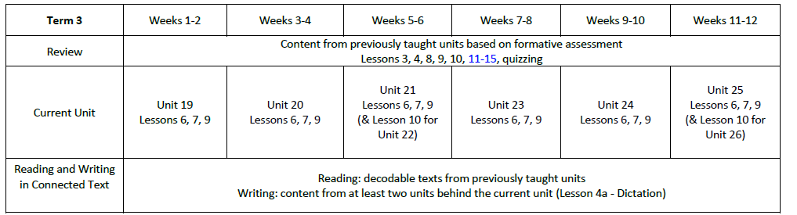

LTP Extended Code Year 2

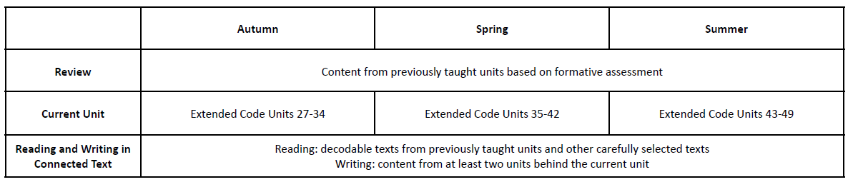

Year 2 Autumn Extended Code
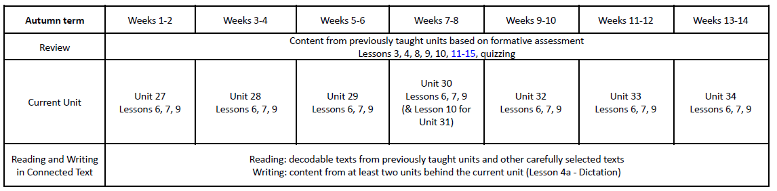

Year 2 Spring Extended Code
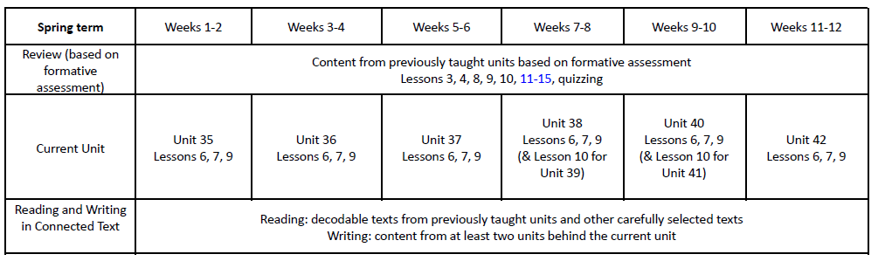

Year 2 Summer


